PHP启动时配置文件显示： Loaded Configuration File => (none)

**错误示下：**

php -i | grep **Load**

Loaded Configuration **File** => (**none**)

libXML Loaded **Version** => 20901

**解决办法：**

**使用strace去追踪一下：**

#strace /usr/local/php/bin/php -i 2> /tmp/1.log

grep 'php.ini' /tmp/1.log 显示如下信息：

**open**("/usr/local/php-7.0.23/bin/php-cli.ini", O_RDONLY) = -1 ENOENT (No such file **or** directory)

**open**("/usr/local/php/etc/php-cli.ini", O_RDONLY) = -1 ENOENT (No such file **or** directory)

**open**("/usr/local/php-7.0.23/bin/php.ini", O_RDONLY) = -1 ENOENT (No such file **or** directory)

**open**("/usr/local/php/etc/php.ini", O_RDONLY) = -1 ENOENT (No such file **or** directory)

openat(AT_FDCWD, "/usr/local/php/etc/php.d", O_RDONLY|O_NONBLOCK|O_DIRECTORY|O_CLOEXEC) = -1 ENOENT (No such file **or** directory)

把php.ini复制到/usr/local/php-7.0.23/bin/下，然后配置文件加载成功了。  
#cp /usr/local/php-7.0.23/etc/php.ini /usr/local/php-7.0.23/bin/  
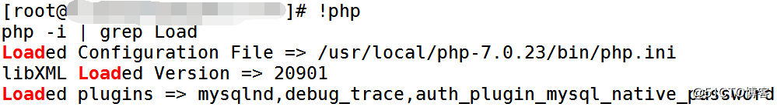

**注：如果编译时指定配置文件路径（--with-config-file-path=/usr/local/php-7.0.23/etc），PHP会先去加载指定的配置文件，如果未找到会去找默认配置文件存放路径。**